Radians- Questions
June 2019 Mathematics Advanced Paper 1: Pure Mathematics 1
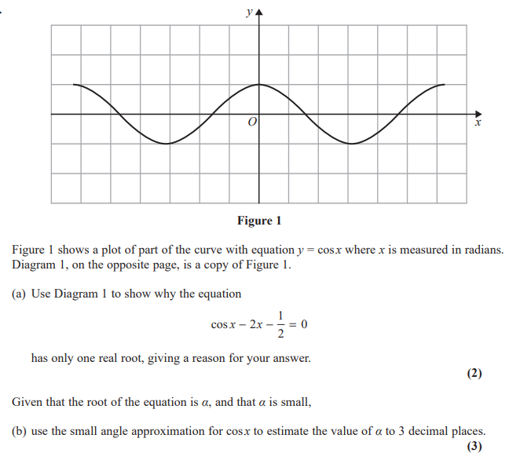

June 2018 Mathematics Advanced Paper 1: Pure Mathematics 1

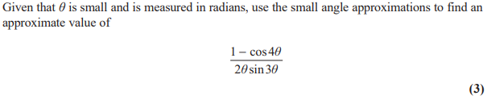

May 2017 Mathematics Advanced Paper 1: Pure Mathematics 2

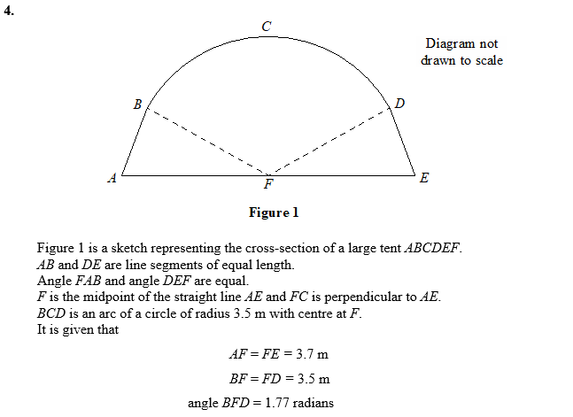

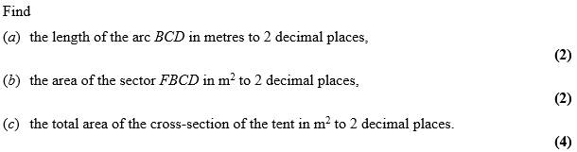

May 2016 Mathematics Advanced Paper 1: Pure Mathematics 2

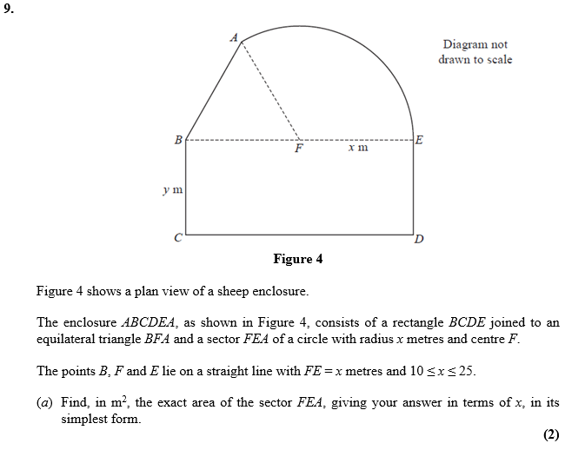
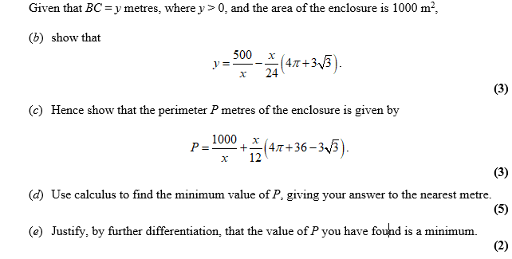
May 2015 Mathematics Advanced Paper 1: Pure Mathematics 2

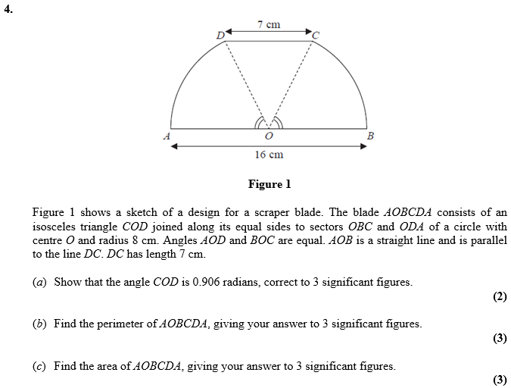
May 2014 Mathematics Advanced Paper 1: Pure Mathematics 2

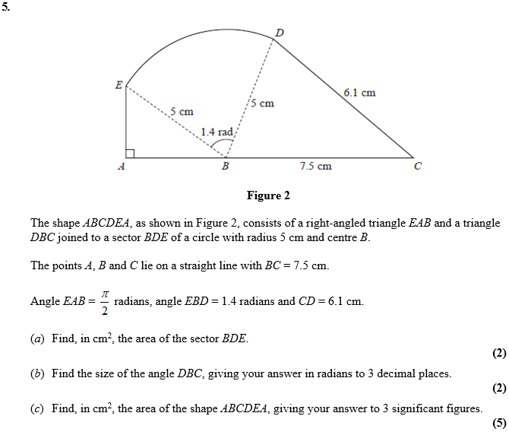

May 2013 Mathematics Advanced Paper 1: Pure Mathematics 2

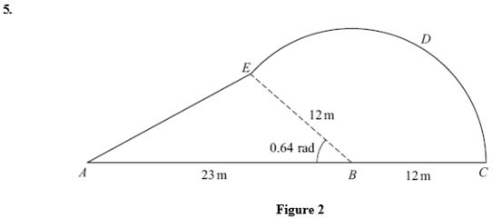
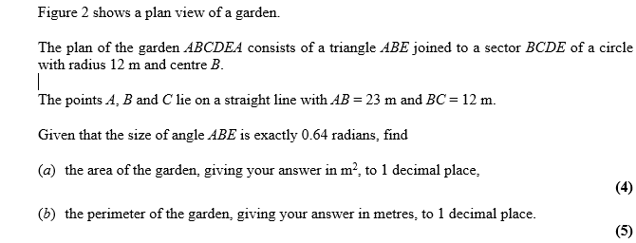

Jan 2013 Mathematics Advanced Paper 1: Pure Mathematics 2

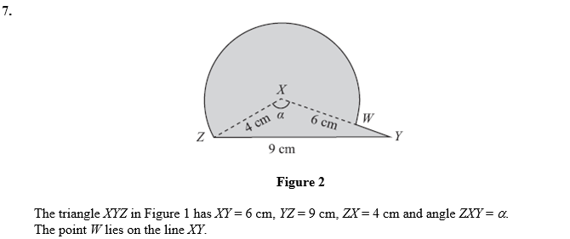
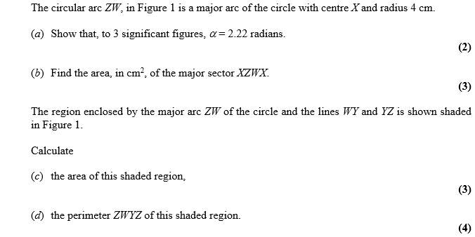

Jan 2012 Mathematics Advanced Paper 1: Pure Mathematics 2

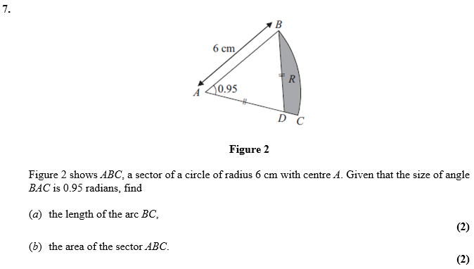
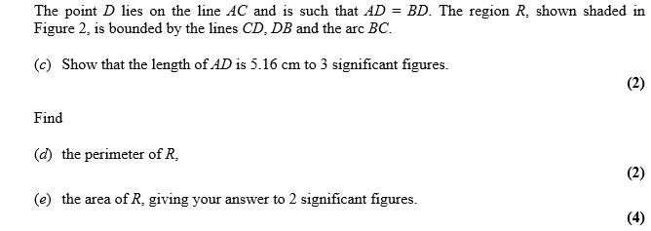

May 2011 Mathematics Advanced Paper 1: Pure Mathematics 2

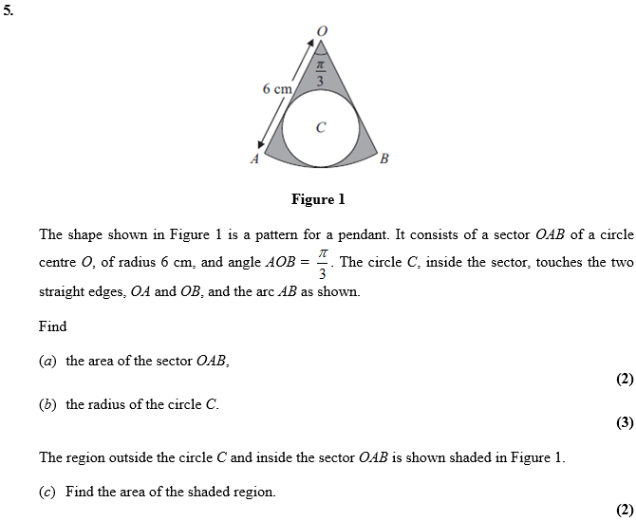

Jun 2010 Mathematics Advanced Paper 1: Pure Mathematics 2

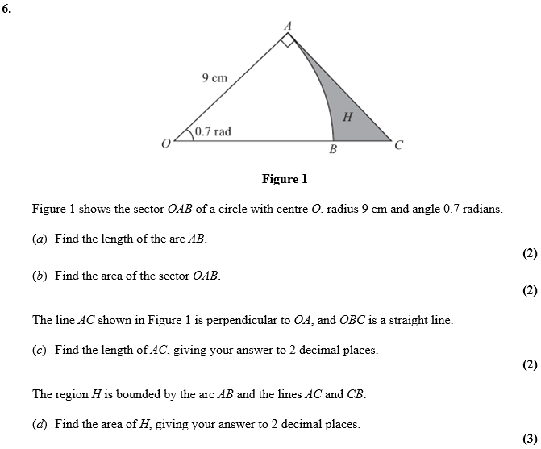

Jan 2010 Mathematics Advanced Paper 1: Pure Mathematics 2

